How to clear the ESM log on a Dell PowerEdge server

Xác định lỗi và loại server bạn đang chạy

The Embedded System Management (ESM) log — also called System Event Log (SEL) or hardware log — reports potential hardware problems in Dell PowerEdge servers. Sometimes, simply turning off the server and disconnecting it from the electrical outlet will remove the error message. Wait approximately 10 seconds, and then reconnect the power cable and restart the server.  
  
Other times, you will need to clear the ESM log to remove the error message. For instance, error code **SEL FULL**indicates that you will need to clear the ESM log. (You will lose the server’s event history.) There are different ways to clear the ESM log.  
  
**To use DSET to Clear the ESM Log**

1. Download and open the [DSET utility](http://support.dell.com/dset).
2. Click the plus (**+**) next to **System**, and then click the plus (**+**) next to **Logs**.
3. Click **ESM** to highlight it.
4. Click **Clear ESM Log** located in the upper-right corner of the page.

**To use OpenManage Server Administrator (OMSA) to clear the ESM log**

1. Start **OpenManage Server Administrator (OMSA)**.
2. Log in to OMSA by entering your username and password, and then press **Enter**.
3. Click the **Logs** tab, and then click **Hardware**.
4. Click **Clear Log** located next to Options.

**To use Dell IT Assistant to clear the ESM log**

1. Start **IT Assistant**.
2. From the middle System Tree bar, select your server by clicking it.
3. Click the **Logs tab**, and then click **Clear Log** in the upper-right corner of the page.

**Find your Dell PowerEdge server model in the chart below for other ways to clear the ESM log:** 

|  |  |
| --- | --- |
| **PowerEdge server model** | **How to clear the ESM log** |
| 2300, 2400, 2450, 2500, 2500SC, 2550, 4300, 4350, 4400, 6300, 6350, 6400, 6450 | **Use the Log2Txt.exe utility to clear the ESM log:**   1. Start your server to the **Log2Txt** utility. 2. When you see the ESM Log main menu appear, press **2** on your keyboard to select **Clear ESM log**. 3. When the ESM Log main menu reappears, press **5** on your keyboard to exit the utility. |
| 1650, 1850, 1800, 2600, 2650, 2800, 4600, 6600, 6650, 7150, 6800, 6850, R900 | **Use the DRAC or ERA to clear the ESM log:**   1. Type the IP address of the Remote Access Controller (RAC) in the web browser address bar, and then press **Enter**. 2. Log in to the RAC. 3. Click the **Logs** tab, and then click **Hardware**. 4. Click **Clear Logs**located in the upper-right corner of the page. |
| 1850, 2800, 2850, 6800, 6850 | **Use the program BMCCFG.exe to clear the ESM logs:**   1. Download and extract the **Dell OpenManage Deployment Toolkit** from [Dell Support](http://www.dell.com/support/drivers/us/en/19/driverdetails?driverid=R157451). 2. Go to ***x*:\Dell\Toolkit\Tools**, where *x* is your primary hard disk drive. 3. Copy the file **BMCCFG.exe** to a bootable floppy disk. 4. Start the server from the bootable floppy disk. 5. At the command prompt, type **bmcc — clearsel**, and then press**Enter**. The message "Clearing SEL" will display while the log clears. |
| 1950, 2900, 2950, DP500, DP600, NF500, NF600 | **Use the BMC/BIOS to clear the ESM log:**   1. To open the BMC menu, press the **Control** + **E** keys during POST. 2. From the list, select **System Event Log**, and then press **Enter**. 3. Select **Clear System Event Log**, and then press **Enter**. |

Quick Tips content is self-published by the Dell Support Professionals who resolve issues daily. In order to achieve a speedy publication, Quick Tips may represent only partial solutions or work-arounds that are still in development or pending further proof of successfully resolving an issue. As such Quick Tips have not been reviewed, validated or approved by Dell and should be used with appropriate caution. Dell shall not be liable for any loss, including but not limited to loss of data, loss of profit or loss of revenue, which customers may incur by following any procedure or advice set out in the Quick Tips.

Setup

Step 1

**wget -q -O - http://linux.dell.com/repo/hardware/latest/bootstrap.cgi | bash**

step 2

# **yum install srvadmin-all**

Step 3 nếu có lỗi conflicts

RROR with rpm_check_debug vs depsolve:

tog-pegasus conflicts with libcmpiCppImpl0-2.0.0Dell-1.1.el5.i386

Yum remove tog-pegasus

Remove xong gõ lệnh của step 2

Xem hướng dẫn sau khi setup

## Install Open Manager Software in Centos

Set up the Dell OpenManage Repository at <http://linux.dell.com/repo/hardware>, like this:

|  |
| --- |
| # **wget -q -O - http://linux.dell.com/repo/hardware/latest/bootstrap.cgi | bash** |

**Note:**The bash pipe is very important.  
Optional Install OpenManage Server Administrator:

|  |
| --- |
| # **yum install srvadmin-all** |

**NOTE:** You can install OMSA on all Linux systems even if the server is not supported. However, complete functionality is not guaranteed.

## Update New Dell Software

This software install establishes two Dell specific repository for the dell hardware and OMSA. After the initial install perform, you should perform an update from the specific Dell respositories. In some Dell server this will make no differnce. In others, new support devices will be installed with update to the overall software. If not done for those server types requiring it, the OMSA software willnot start propertly.

To do this without a required reboot for other software for other software updates, temporarily disable the other respositories for the yum update. First list them out and them disabled them in the syntax with yum.

|  |
| --- |
| # **yum repolist**  Loaded plugins: dellsysid, fastestmirror, security  Loading mirror speeds from cached hostfile  * Webmin: download.webmin.com  * base: mirrors.versaweb.com  * extras: mirrors.cicku.me  * rpmforge: mirror.hmc.edu  * updates: mirrors.cicku.me  repo id repo name status  Webmin Webmin Distribution Neutral 118  base CentOS-5 - Base 3,591  **dell-omsa-indep** Dell OMSA repository - Hardware independent 1,492  **dell-omsa-specific** Dell OMSA repository - Hardware specific 12  extras CentOS-5 - Extras 273  rpmforge RHEL 5 - RPMforge.net - dag 11,133  updates CentOS-5 - Updates 934  repolist: 17,553  # **yum update --disablerepo=Webmin --disablerepo=base --disablerepo=extras --disablerepo=rpmforge --disablerepo=updates** |

## Open TCP Port 1311

Next open port 1311 (e.g. **system-config-securitylevel**):

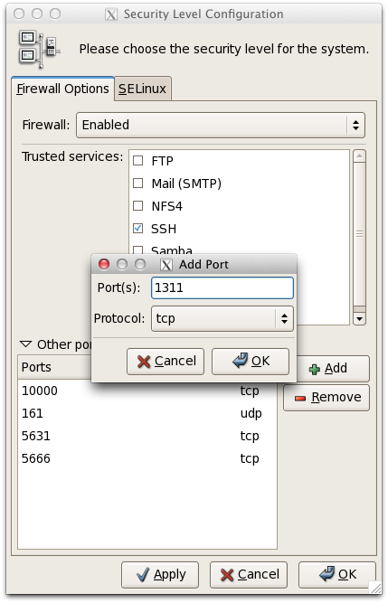

## Enable Web Server

Enabled and start the httpd server. This may require that you edit the file /etc/httpd/conf/httpd.conf and assign the fully qualified named. This error occurs if fully qualified named (FQDN) is not specified:

|  |
| --- |
| # **service httpd restart** Stopping httpd: [ **OK** ] Starting httpd: httpd: apr_sockaddr_info_get() failed for xenserv102.hq.freightgate.com httpd: Could not reliably determine the server's fully qualified domain name, using 127.0.0.1 for ServerName  [ **OK** ] # |

Edit the file **/etc/httpd/conf/httpd.conf** and assign the fully qualified named for the parameter "**ServerName**" to eliminate this error:

|  |
| --- |
| # If your host doesn't have a registered DNS name, enter its IP address here. # You will have to access it by its address anyway, and this will make # redirections work in a sensible way. # **ServerName server.mydomain.com**   # # UseCanonicalName: Determines how Apache constructs self-referencing # URLs and the SERVER_NAME and SERVER_PORT variables. # When set "Off", Apache will use the Hostname and Port supplied |

Restarting the services will eliminate this error:

|  |
| --- |
| # **service httpd restart** Stopping httpd: [ **OK** ] Starting httpd: [ **OK** ] # |

Make sure the http service is enable to start automatically (e.g.**system-config-services**):

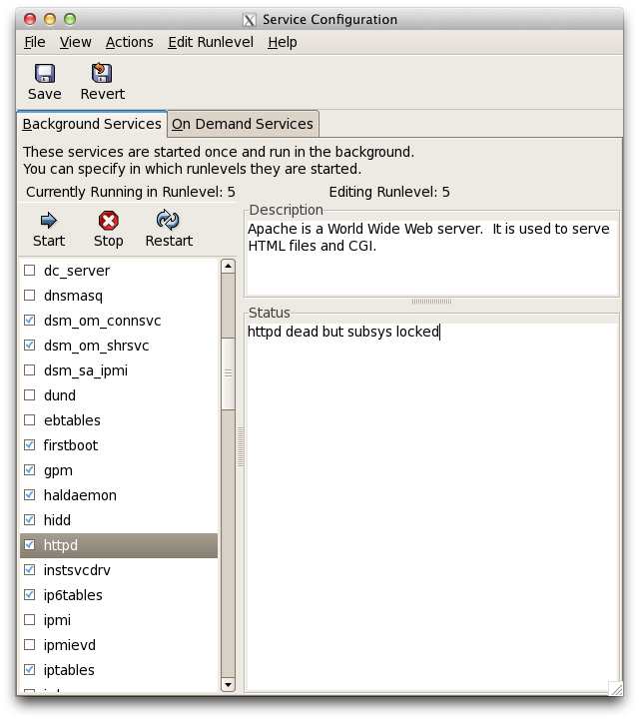

**Note:** dsm_om_connsvc, dsm_om_shrsvc, dsm_sa_ipmi and instsvcdrv services have been added by the Open Manager install.

## Start Dell Services

Use the script **srvadmin-services.sh** in the **/opt/dell/srvadm/sbin** directory to start the dell services and enable them to run at boot up.

|  |
| --- |
| # **/opt/dell/srvadmin/sbin/srvadmin-services.sh start**  Starting Systems Management Device Drivers:  Starting dell_rbu: [ **OK** ]  Starting ipmi driver: [ **OK** ]  Starting Systems Management Data Engine:  Starting dsm_sa_datamgrd: [ **OK** ]  Starting dsm_sa_eventmgrd: [ **OK** ]  Starting DSM SA Shared Services: [ **OK** ]    Starting DSM SA Connection Service: [ **OK** ]    # **/opt/dell/srvadmin/sbin/srvadmin-services.sh enable**  racsvc 0:off 1:off 2:on 3:on 4:on 5:on 6:off  instsvcdrv 0:on 1:off 2:off 3:on 4:on 5:on 6:on  dataeng 0:off 1:off 2:off 3:on 4:on 5:on 6:off  dsm_om_shrsvc 0:off 1:off 2:off 3:on 4:on 5:on 6:off  dsm_om_connsvc 0:off 1:off 2:off 3:on 4:on 5:on 6:off  ipmi 0:off 1:off 2:off 3:off 4:off 5:off 6:off  # |

**Note**: If you get a failure on say "Staring DMA SA Connection Service:" It is probably because you have not perform a yum update from the Dell repository.

Usage: srvadmin-services.sh {start|stop|status|restart|enable|disable|help}

start : starts Server Administrator services

stop : stops Server Administrator services

status : display status of Server Administrator services

restart: restart Server Administrator services

enable : Enable Server Administrator services in runlevels 2, 3, 4, and 5

disable: Disable Server Administrator services in runlevels 2, 3, 4, and 5

help : Displays this help text

Checking it Works  
  
Check that is work by using a brower to display the web page using https and port 1311.

[https://localhost:1311](https://localhost:1311/) or use the ip address of the server instead of local host.

This will be a secure access and will require that you add the certificate. Follow the normal dialogs and add the exception.

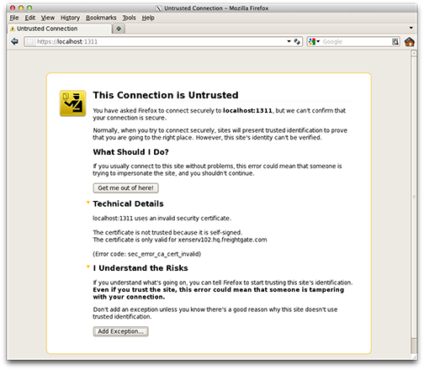

The next dialog will probaly tell you, that your browsers is not authorized (Safari issue).

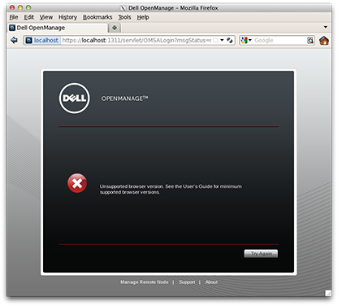

Ignore this dialog and just click "**Try Again**". This will bring up the login screen.

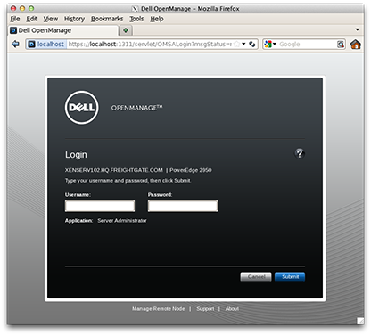

Enter the "**root**" and the **root** password for this machine. The following screen will appears.

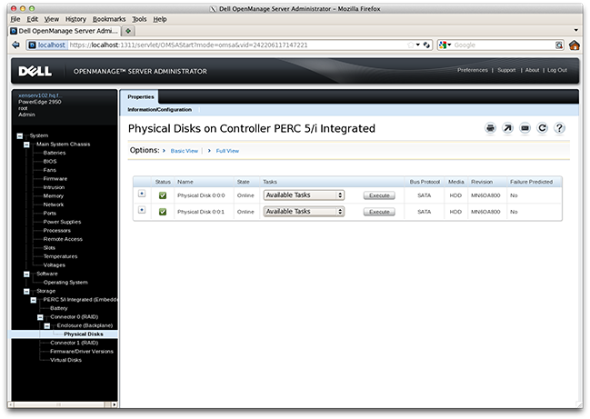

**Note:** If the website does note provide a list, restart the Dell services:

|  |
| --- |
| # **/opt/dell/srvadmin/sbin/srvadmin-services.sh restart**  Starting Systems Management Device Drivers:  Starting dell_rbu: [ **OK** ]  Starting ipmi driver: [ **OK** ]  Starting Systems Management Data Engine:  Starting dsm_sa_datamgrd: [ **OK** ]  Starting dsm_sa_eventmgrd: [ **OK** ]  Starting DSM SA Shared Services: [ **OK** ]    Starting DSM SA Connection Service: [ **OK** ]    # |